Java Program Execution Process
Name: Yash raj
Roll: 25scs1003005512

1. Screenshots to Include
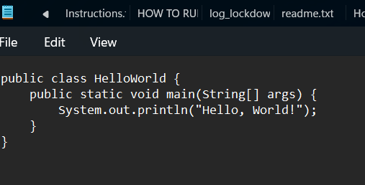
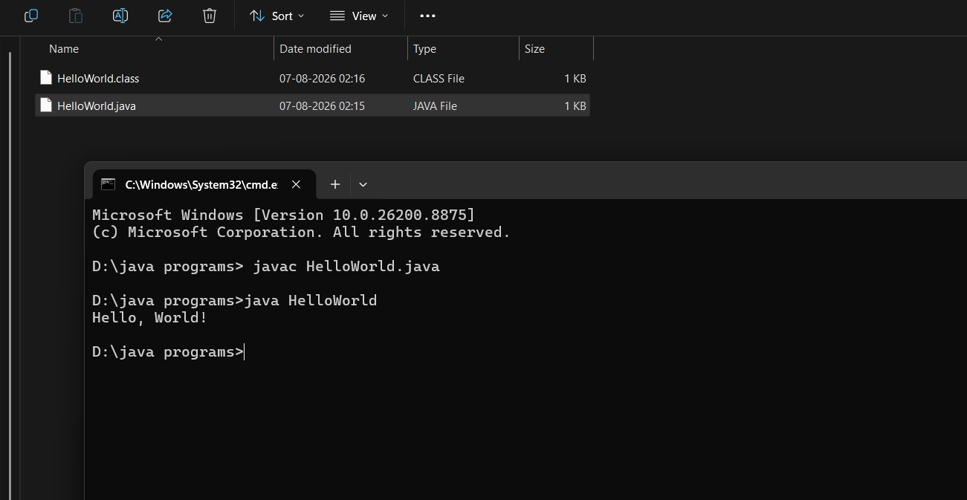

2. Brief Answers

What is a Java program?
A Java program is a set of instructions written in the Java programming language. It is compiled into bytecode and executed by the Java Virtual Machine (JVM).

What is the purpose of the main() method?
The main() method is the entry point of every standalone Java application. The JVM starts executing the program from this method.

What is the difference between javac and java?
javac is the Java compiler that converts .java source files into .class bytecode files. The java command runs the compiled bytecode using the JVM.

3. Java Program Structure (Detailed)
A Java program is generally organized into the following parts:
1. Documentation/Comments
- Used to explain the program.
- Single-line (//), multi-line (/* */), and Javadoc (/** */) comments improve readability.
2. Package Declaration (Optional)
- Declares the package in which the class belongs.
- Example: package mypackage;
3. Import Statements (Optional)
- Import predefined classes and packages.
- Example: import java.util.Scanner;
4. Class Declaration
- Every Java program is written inside a class.
- Example: public class HelloWorld { }
5. main() Method
- Syntax:
public static void main(String[] args)
- public: accessible by JVM.
- static: can be called without creating an object.
- void: returns no value.
- String[] args: stores command-line arguments.
6. Statements
- Instructions executed sequentially inside methods.
- Examples include variable declarations, calculations, loops, and method calls.
7. Output Statements
- System.out.println() displays output.
- System.out.print() prints without moving to the next line.
Execution Process:
• Write source code in HelloWorld.java.
• Compile using: javac HelloWorld.java.
• The compiler generates HelloWorld.class (bytecode).
• Run the program using: java HelloWorld.
• The JVM loads and executes the bytecode and displays the output.

